**CIRCUIT:**

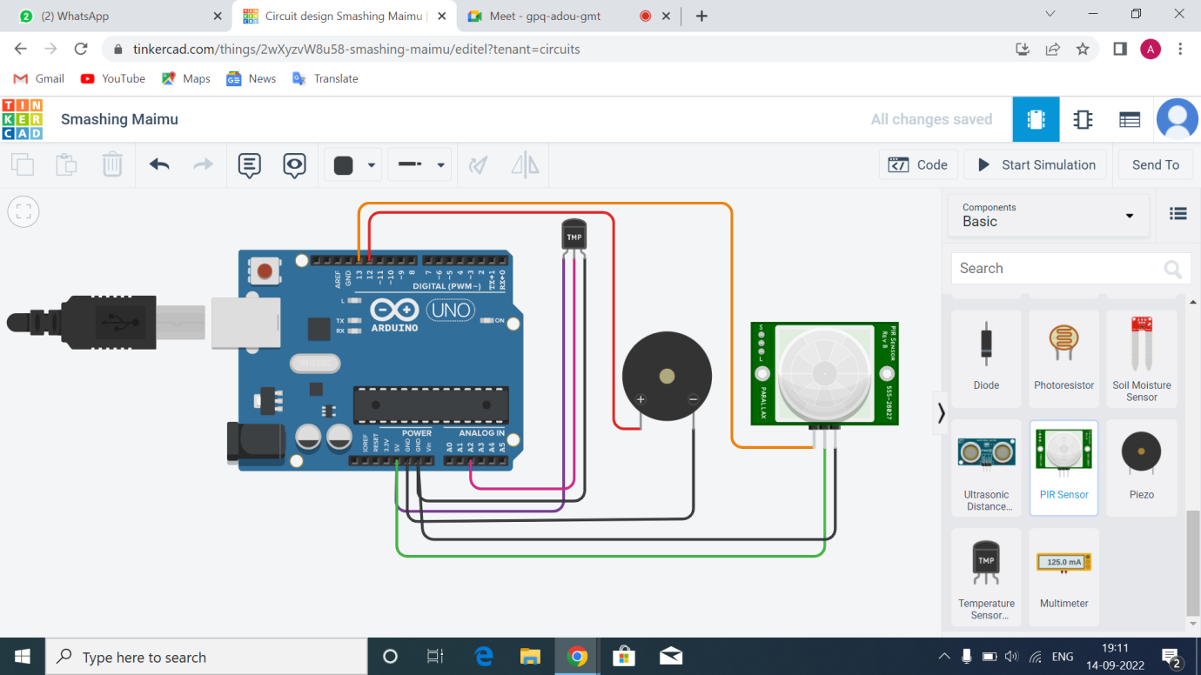

**CODE:**

**// C++ code**

**//**

**void setup()**

**{**

**Serial.begin(9600);**

**pinMode(13,INPUT);**

**pinMode(12,OUTPUT);**

**}**

**void loop()**

**{**

**double data=analogRead(A2);**

**double n=data/1024;**

**double volt=n*5;**

**double off=volt-0.5;**

**double temperature=off*100;**

**int motion=digitalRead(13);**

**for(int freq=4;freq<=5;freq++)**

**{**

**if(temperature>=60)**

**{**

**Serial.println("Temperature is above 60");**

**tone(12,freq);**

**delay(100);**

**}**

**else**

**{**

**Serial.println("Temperature is below 60");**

**noTone(12);**

**}**

**}**

**for(int freq=2;freq<=3;freq++)**

**{**

**if(motion==1)**

**{**

**Serial.println("Motion Detected");**

**tone(12,freq);**

**delay(200);**

**}**

**else**

**{**

**Serial.println(" No Motion");**

**noTone(12);**

**}**

**}**

**}**

**OUTPUT:**

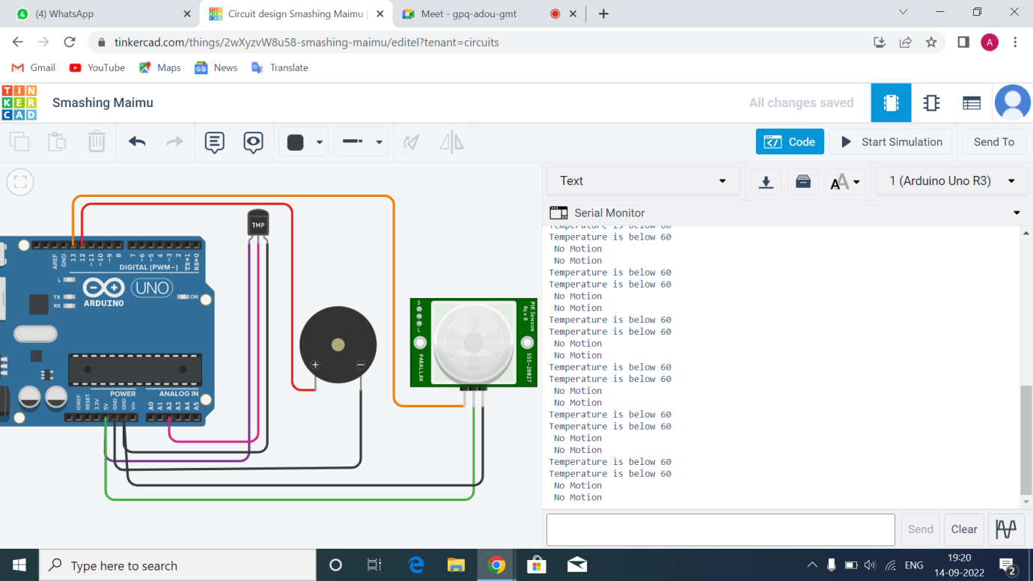

**DRIVE LINK:**

[**https://docs.google.com/document/d/1jYa2NNArI-uDLkuBVCtMwsKMm1F5Ev-Q/edit?usp=sharing&ouid=112269385202087262414&rtpof=true&sd=true**](https://docs.google.com/document/d/1jYa2NNArI-uDLkuBVCtMwsKMm1F5Ev-Q/edit?usp=sharing&ouid=112269385202087262414&rtpof=true&sd=true)